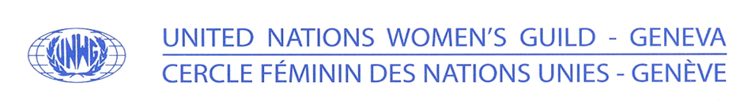

PROJECT APPLICATION FORM 2023

Information about the organisation
Project Title:
Name of applying Institution:
Street:
City:
Country:
Website:
Name of Project Manager:
Address (if different from above)
Phone number
E-mail address:
Nature of organisation: | __Orphanage | __Day Care Centre
 | __School | __Rehabilitation Centre
 | __Shelter | __Hospital
 | __Other (specify)___________________________________
Is your organisation an NGO or charitable organisation registered with your government? (current/valid certificate of registration, not older than 2 years, must be attached) |  |  | YES | NO
Is your organisation a government organisation? |  |  | YES | NO
Date of creation of organisation:
How does your organisation finance itself? | __Donations/fund raising | __Membership Fees
 | __Government | __Other: _____________
 | __International organisations
Annual expenditure of your organisation:
How many of staff are salaried?
How many staff are volunteers?
Did your organisation receive funds from UNWG-Geneva before? |  |  | YES | NO
If organisation was funded before, please give details on the year it was funded, the number of the project and its scope.
Objectives and goals of the organisation (attach annual report if available):
Activities and projects undertaken by the organisation, including its funding sources, in the past year:
Geographical location of the project and infrastructure (accessibility of roads, water, transport):

Information about the project proposal
Describe the objectives of the project.
What problems will the project address in your community? Explain how many people will benefit and how the project will be sustained and continued in the future. Attach additional documents, if necessary.
Provide in chronological order the steps of the implementation including planning phase. Attach additional documents, if necessary.

Detailed Budget Proposal
List main budget lines below and attach a detailed list of items to be funded by order of priority (in local currency, with conversion to Swiss Francs) and with supporting pro forma invoices:
Budget lines: | Local currency:  ___________ | CHF
1.
2.
3.
4.
5.
Estimated total cost of the project:
Amount requested from UNWG Geneva in CHF:
Date of exchange rate:
Amount requested from other donors:
List other donors and amounts already secured (add lines, if needed):
1.
2.
3.
When do you expect the project to start?
When do you expect the project to finish?

Bank details

NOTE: The bank account should be in the name of the institution (not in the name of an individual person) applying for funds and in the country of implementation.
Name of the Local Bank
Street & No.
Postcode & City
Country
SWIFT code (BIC)
Name of the Institution - Account Holder
Street & No.
Postcode & City
Country
IBAN number

Statement by Project Manager and Treasurer
I, the Project Manager, certify that the above information is correct and that the project will adhere to the Universal Declaration of Human Rights and the UN Convention on the Rights of the Child. The services of our organization are available to all women and children without discrimination, regardless of race, gender, ethnic origin, caste or religion. Moreover, the project will abide by ethical standards of child protection, health, and environmental protection.
If this project receives financial support from UNWG-Geneva, I undertake to provide UNWG-Geneva with the acknowledgement upon receipt of the funds, as well as detailed evaluation report (text, photos and invoices) of the project no later than 6 months after receiving the funds.

Name of Project Manager: | Signature:
Place and date:
Name of Treasurer: | Signature:
Place and date:

Checklist for the UNWG Member - Project Sponsor:

Before sending the project application to the UNWG-Geneva, please check that you have:
□ paid your membership fee for 2023,
□ attached up to date and valid NGO certificate (not older than 2 years),
□ attached pro-forma invoices for all the items you would like to purchase with the UNWG grant,
□ provided all documentation with necessary translation in either English or French (including the budget),
□ submitted to UNWG-Geneva full reports of the past projects (narrative, and financial reports as well as photos) in the event you have sponsored projects in the past with the UNWG-Geneva,
□ actively participated in UNWG-Geneva funding efforts by (please specify):
___________________________________________________________________________________
___________________________________________________________________________________
___________________________________________________________________________________
□ read through the UNWG Guidelines for project application and confirm that your project meets the criteria.
How did you find out about the project?

Name of the UNWG Member: | Signature:
Place and date:
Phone: | E-mail:

Disclaimer
If this project receives financial support from UNWG-Geneva, we, the Project Manager and the Project Sponsor, give the authority to the UNWG to use any information, photos, films or presentation pertaining to this project for purposes of exhibits, promotions and publications of UNWG. We understand that the UNWG is not liable for any negative consequences arising from the use of its funds.

Signature of Project Manager:
Signature of Project Sponsor:

